**DAILY ONLINE ACTIVITIES SUMMARY**

|  |  |  |  |  |  |  |  |
| --- | --- | --- | --- | --- | --- | --- | --- |
| **Date:** | **13/06/2020** | | | | **Name:** | **Imran Khan** | |
| **Sem & Sec** | **8th A** | | | | **USN:** | **4AL16CS040** | |
| **Online Test Summary** | | | | | | | |
| **Subject** | | **IOT** | | | | | |
| **Max. Marks** | | **30** | | **Score** | | **29** | |
| **Certification Course Summary** | | | | | | | |
| **Course** | **Python Quiz** | | | | | | |
| **Certificate Provider** | | | **PVG college** | **Duration** | | | **2 HOURS** |
| **Coding Challenges** | | | | | | | |
| Problem Statement:  Write a C Program to calculate electricity bill.. | | | | | | | |
| **Status: Solved** | | | | | | | |
| **Uploaded the report in Github** | | | | **yes** | | | |
| **If yes Repository name** | | | | **Imran040** | | | |
| **Uploaded the report in slack** | | | | **yes** | | | |

Online test details:

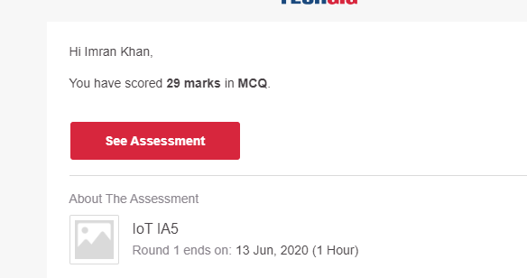

**Certification Course Details**:



**Coding Challenges Details**:

**program1:**

|  |  |  |  |
| --- | --- | --- | --- |
|  | | | |
|  | |
| #include<stdio.h> | |
|  | |  |
|  | | void main() |
|  | | { |
|  | | int units, cost = 0; |
|  | |  |
|  | | printf("Enter no. of units: "); |
|  | | scanf("%d", &units); |
|  | |  |
|  | | if (units <= 100) |
|  | | { |
|  | | cost = units * 10; |
|  | | } |
|  | | else if (units <= 200) |
|  | | { |
|  | | cost = (100 * 10) + (units - 100) * 15; |
|  | | } |
|  | | else if (units <= 300) |
|  | | { |
|  | | cost = (100 * 10) + (100 * 15) + (units - 200) * 20; |
|  | | } |
|  | | else if (units > 300) |
|  | | { |
|  | | cost = (100 * 10) + (100 * 15) + (100 * 20) + (units - 300) * 25; |
|  | | } |
|  | |  |
|  | | printf("Cost: %d", cost); |
|  | | } |